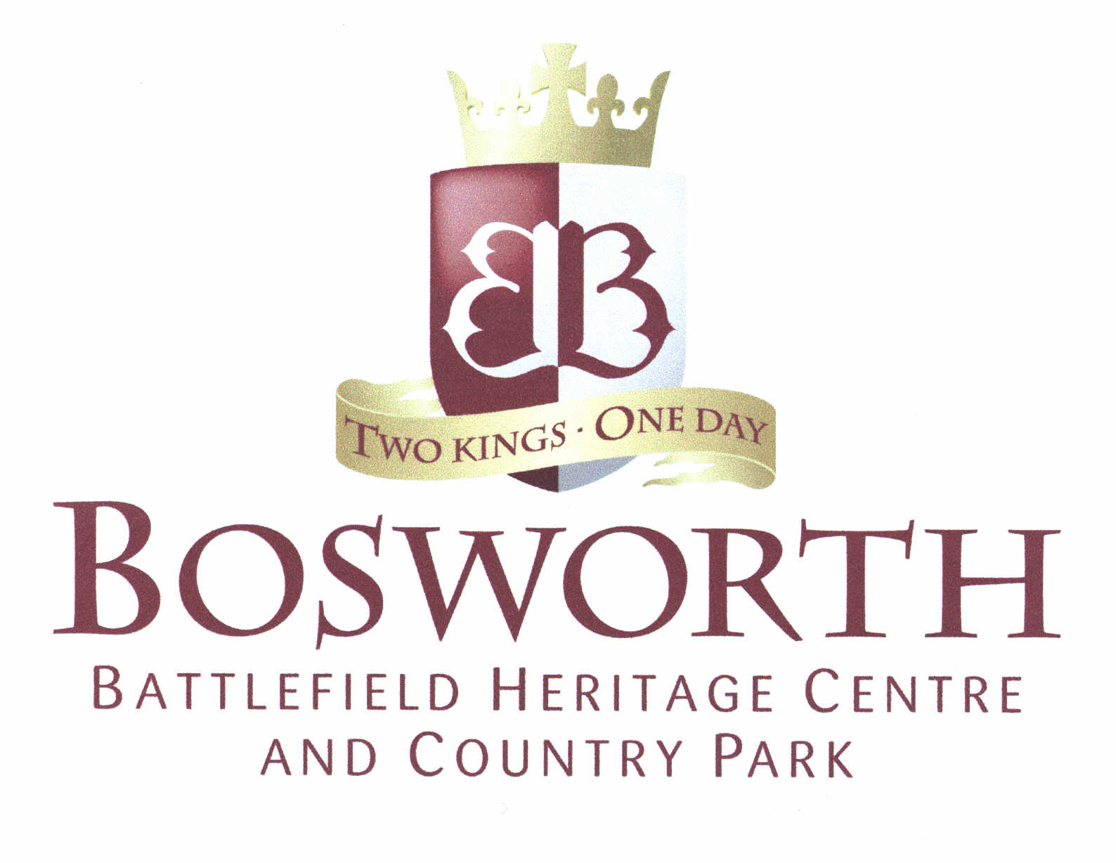

To whom it may concern
Reference for Sara Mair – Mair Education
I am delighted to provide a reference for Sara Mair of Mair Education, with regard to work she has recently completed for Bosworth Battlefield Heritage Centre. Sara was contracted to research and design a Citizenship facilitated learning session based on conflict and civil wars and produce online supporting resources.
Sara demonstrated creative and resourceful research skills in identifying and selecting a range of objects and sources for inclusion in the session as well as to support teachers through the online resources. Sara’s rigorous attention to detail and clear understanding of the needs of teachers and pupils when accessing museum collections and providing other supporting materials were key to the success of the end result.
The session was designed to increase Bosworth’s provision for pupils at Key Stage 3, and through her creative approach to learning and experience in increasing access for teachers and pupils to a wide range of subjects through museum collections, Sara created an innovative range of practical yet enjoyable interactive activities grounded in robust links to the curriculum designed to help pupils develop confidence in using sources and artefacts to challenge assumptions and develop thinking skills.
Sara also produced online learning resources designed to be used before, during and after a visit to Bosworth. These learning resources along with the handbook Sara produced for museum staff, delivering the facilitated learning session, demonstrated her skills in writing in a concise and accessible style and was clearly informed by her comprehensive understanding of best practice in museum education provision.
Part of Sara’s role involved undertaking a research and piloting programme with local teachers and pupils to identify requirements for the facilitated session and supporting resources as well as barriers and incentives to use. I was highly impressed by Sara’s ability to engage with and motivate teachers from a range of schools and her commitment to helping Bosworth develop relationships with the schools as well as raising awareness of our education provision. In addition, I had total confidence in Sara’s skill to deal with what is a very emotive and sensitive issue for some visitors.
Sara’s involvement was dynamic throughout the entire project with her clear communication ensuring the end result was completed to time, budget end exceeded our expectations. The piece of work clearly benefited from Sara’s hard work and commitment and the amount of work that she undertook for the project was amazing – I cannot recommend her highly enough. If you need any more information, please contact me on 01455 293341, I would be delighted to go through any other information you may require.
Yours sincerely

Kath Perry, Lifelong Learning Officer, Leicestershire County Council Environment and Heritage Service

